Financial Analysis

Blog Link: <https://aws.amazon.com/blogs/industries/empowering-analysts-to-perform-financial-statement-analysis-hypothesis-testing-and-cause-effect-analysis-with-amazon-bedrock-and-prompt-engineering/>

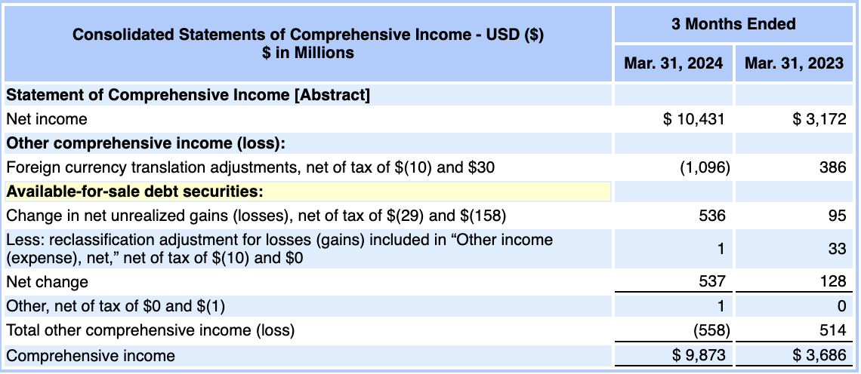

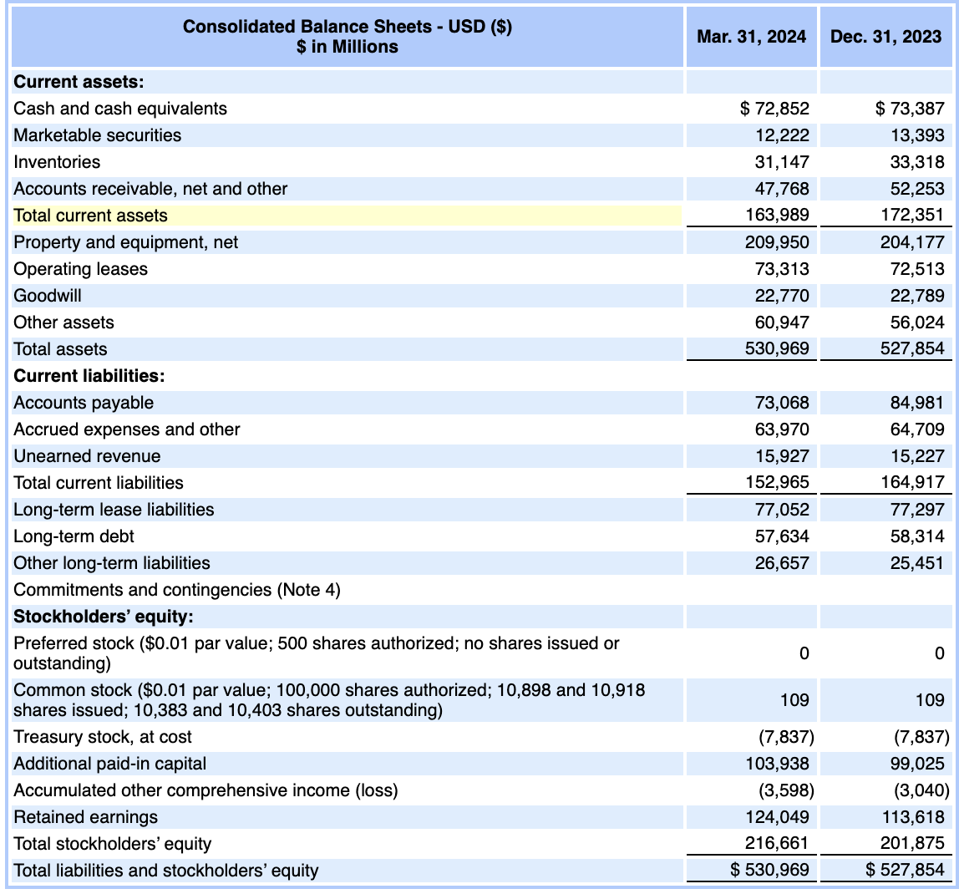

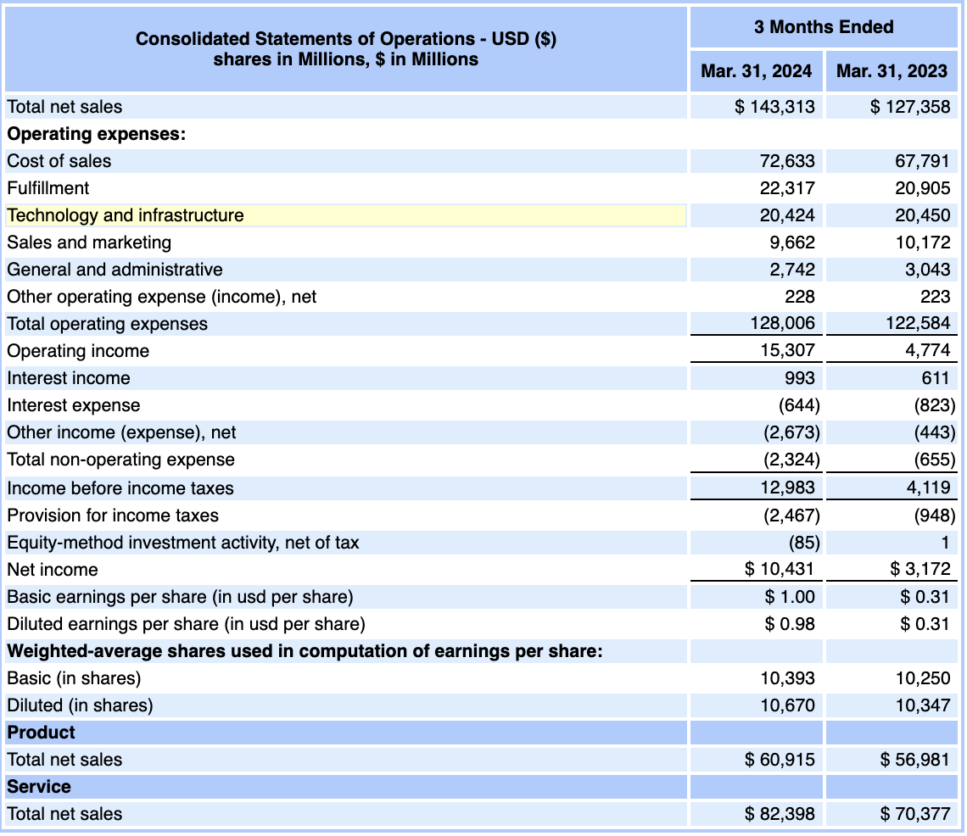

**Prompt:**

How much debt does the company have?

**Response:**

*According to the consolidated balance sheet shown in the first image, the company's long-term debt as of March 31, 2024, was 57,634 million.*

**Prompt:**

Does the company have more current assets and current liabilities?

**Response:**

*Yes, based on the consolidated balance sheet, the company has more current assets than current liabilities.*

*As of March 31, 2024: Total current assets = 163,989 million Total current liabilities = 152,965 million*

*So the company's current assets exceed its current liabilities by 11,024 million, indicating it has sufficient short-term assets to cover its short-term obligations.*

**Prompt:**

Does the company have a lot of goodwill on its balance sheet?

**Response:**

*Yes, the company does have a significant amount of goodwill on its balance sheet. As per the consolidated balance sheet, the goodwill value as of March 31, 2024 is 22,770 million.*

*Goodwill is an intangible asset that represents the excess purchase price paid by a company over the fair value of the net tangible and identifiable intangible assets acquired in a business combination or acquisition.*

*Having a relatively large goodwill balance of 22.77 billion suggests that the company has made major acquisitions in the past, paying premiums over the fair values of the acquired companies' net assets. Goodwill is an asset that carries risk of future impairment if the acquired businesses underperform expectations.*

*So while a high goodwill number is not necessarily a red flag, it does indicate that a substantial portion of the company's assets are tied up in acquired intangible values rather than tangible productive assets. Close monitoring of the goodwill asset's performance is warranted.*

**Prompt:**

Are revenues steadily increasing over time?

**Response:**

*Based on the information provided in the Consolidated Statements of Operations, the company's revenues (Total net sales) are indeed increasing steadily over time.*

*In the quarter ended March 31, 2024, Total net sales were 143,313 million. In the quarter ended March 31, 2023, Total net sales were 127,358 million.*

*This shows a year-over-year increase in Total net sales of around 12.5% from Q1 2023 to Q1 2024.*

*While only two quarterly data points are given, the significant increase in revenues suggests a positive trend of steadily rising sales for the company over the past year.*

*Additionally, when we look at the Product and Service segment breakdowns, both segments exhibited revenue growth year-over-year:*

*Product net sales increased from 56,981 million in Q1 2023 to 60,915 million in Q1 2024. Service net sales grew from 70,377 million in Q1 2023 to 82,398 million in Q1 2024.*

*So based on the limited data provided, there are clear indications that the company's total revenues, as well as revenues from its two main business segments, are steadily increasing over time.*

**Prompt:**

Does the company need a lot of COGS to sell its products?

**Response:**

*Yes, the company appears to have relatively high cost of goods sold (COGS) or cost of sales compared to its total net sales.*

*From the Consolidated Statements of Operations: In Q1 2024, the company's cost of sales was 72,633 million out of total net sales of 143,313 million.*

*This means the cost of sales accounted for approximately 50.7% of the total net sales in that quarter (72,633 / 143,313 = 0.507 or 50.7%).*

*In Q1 2023, the cost of sales was 67,791 million out of 127,358 million in total net sales, which is around 53.2%.*

*While there was a slight improvement year-over-year, the cost of sales still constituted over 50% of the company's net sales in both quarters.*

*A high cost of sales ratio is typical for companies dealing in physical products or merchandise that require substantial raw materials, manufacturing, and inventory costs.*

*The company also reports separate revenue figures for its Product and Service segments, suggesting it likely has a product-based business line that incurs significant COGS expenditures.*

*So in summary, yes, the data indicates the company needs to incur relatively high costs of goods sold or cost of sales to generate its product sales revenue, which is characteristic of product-oriented businesses.*

**Prompt:**

How much revenue is translated into net income?

**Response:**

*To calculate how much of the company's revenue is translated into net income, I'll use the figures from the most recent quarter (Q1 2024) in the Consolidated Statements of Operations:*

*Total Net Sales (Revenue) in Q1 2024: 143,313 million Net Income in Q1 2024: 10,431 million*

*To find what percentage of revenue became net income, I'll divide net income by total net sales:*

*Net Income / Total Net Sales = 10,431 million / 143,313 million = 0.0728 or 7.28%*

*So in the quarter ended March 31, 2024, approximately 7.28% of the company's total revenue translated into net income or profit after accounting for all expenses, taxes, and other items.*

*This net income margin of 7.28% indicates that out of every 1 in revenue, about 0.073 flowed through to the company's bottom line net profit.*

*While not extremely high, a 7.28% net profit margin is still a reasonably healthy profitability level for a company, especially one with high cost of sales like this company appears to have based on the previous information provided.*

**Prompt:**

Are most earnings translated into operating cash flow?

**Response:**

*Unfortunately, the information provided in the images does not include any cash flow statements, which would be needed to directly analyze the relationship between the company's earnings and operating cash flows.*

*However, based on the other financial statements shown:*

1. *The income statements indicate the company had a strong net income of 10,431 million in Q1 2024.*
2. *The balance sheets show a modest increase in cash and cash equivalents from 73,387 million on Dec 31, 2023 to 72,852 million on Mar 31, 2024.*

*This relatively small change in cash balances compared to the large net income number suggests that a significant portion of earnings may not be immediately translating into operating cash flows.*

*There could be several potential reasons for this:*

1. *Earnings are being used to fund capital expenditures, acquisitions, debt repayments or other investing/financing outflows.*
2. *There are significant non-cash items like depreciation included in net income.*

**Prompt:**

Does the company have positive free cash flow (operating cash flow - CAPEX)?

**Response:**

*Unfortunately, without the company's cash flow statement, I cannot definitively calculate or determine if the company has positive free cash flow or not.*

*Free cash flow is typically calculated as:*

*Free Cash Flow = Operating Cash Flow - Capital Expenditures (CAPEX)*

*The information provided in the images does not disclose the operating cash flow or capital expenditure figures explicitly.*

*However, based on the balance sheets, we can make some inferences about capital expenditures:*

1. *The Property and Equipment, net balance increased from 204,177 million on Dec 31, 2023 to 209,950 million on Mar 31, 2024.*

*This increase of 5,773 million likely represents capital expenditures made to acquire new property, plant and equipment during Q1 2024, net of depreciation.*

1. *Without knowing the operating cash flow number, it's impossible to determine if this 5,773 million in estimated CAPEX was fully covered by internal operating cash generation or not.*

*So in summary, while I can estimate the CAPEX number for Q1 2024, the lack of a cash flow statement prevents me from calculating the operating cash flow and therefore assessing if the company had positive or negative free cash flow during that period.*

*Analyzing free cash flow would require the additional cash flow data that is missing from the information provided. But the capital expenditure estimate provides some insight into one component of free cash flow.*

**Prompt:**

Did the company manage to increase its cash position compared to last year?

**Response:**

*Based on the information provided in the consolidated balance sheets, it does not appear that the company managed to increase its cash position compared to the prior year.*

*The cash and cash equivalents balances shown are:*

*As of March 31, 2024: 72,852 million As of December 31, 2023: 73,387 million*

*The cash balance as of March 31, 2024 (72,852 million) is actually lower than the balance at the end of the previous year on December 31, 2023 (73,387 million).*

*So the company's cash position decreased by 535 million over the 3-month period from December 31, 2023 to March 31, 2024.*

*Without access to the cash flow statement, it's difficult to pinpoint the exact reasons for this decline in cash balances. It could be due to factors like capital expenditures, acquisitions, debt repayments, share buybacks or other cash outflows exceeding the cash inflows during the quarter.*

*But based solely on the balance sheet data provided, the company's cash and cash equivalent holdings decreased rather than increased when compared to the prior year-end balance as of December 31, 2023.*

**Prompt:**

Perform a financial analysis by calculating the ratios from the data in the images. Interpret the ratios. Give your answer in Tabular format indifferent section with 3 columns - Ratios for that section, Ratio calculation, Interpretation for the ratio values. For every ratio give calculations/basis/justifications. Do not make up answers/numbers/data. Answer only if you know it.

Activity Ratios:

| Activity Ratios | Ratio calculation |

|-----------------|-------------------|

| Inventory turnover | Cost of goods sold / Average inventory |

| Days of inventory on hand (DOH) | Number of days in period / Inventory turnover |

| Receivables turnover | Revenue or Net credit sales / Average receivables |

| Days of sales outstanding (DSO) | Number of days in period / Receivables turnover |

| Payable Turnover | Purchases / Average payables |

| Number of days of payables | Number of days in period / Payable turnover |

| Working capital turnover | Revenue / Average working capital |

| Fixed assets turnover | Revenue / Average fixed assets |

| Total assets turnover | Revenue / Average total assets |

**Response:**

*Here's a financial analysis with activity ratios calculated from the data provided in the images:*

*Activity Ratios:*

|  |  |  |
| --- | --- | --- |
| ***Activity Ratios*** | ***Ratio Calculation*** | ***Interpretation*** |
| *Inventory turnover* | *Cost of goods sold / Average inventory = 72,633 / ((31,147 + 33,318) / 2) = 2.28 times* | *The inventory turned over 2.28 times during the quarter, indicating relatively slow inventory movement.* |
| *Days of inventory on hand (DOH)* | *90 days / 2.28 = 39.47 days* | *On average, inventory was held for around 39 days before being sold or used.* |
| *Receivables turnover* | *Total net sales / Average receivables = 143,313 / ((47,768 + 52,253) / 2) = 3.04 times* | *Accounts receivable turned over 3.04 times per quarter, suggesting a moderate collection period.* |
| *Days of sales outstanding (DSO)* | *90 days / 3.04 = 29.61 days* | *It took around 30 days on average to collect cash after a sale was made.* |
| *Payable Turnover* | *Cost of goods sold / Average payables = 72,633 / ((73,068 + 84,981) / 2) = 0.95 times* | *Accounts payable turned over less than once per quarter, indicating a relatively slow payables payment cycle.* |
| *Number of days of payables* | *90 days / 0.95 = 94.74 days* | *The company took around 95 days on average to pay its suppliers or creditors.* |
| *Working capital turnover* | *Total net sales / Average working capital = 143,313 / ((163,989 + 172,351) / 2) = 0.89 times* | *Working capital turned over less than once per quarter, suggesting potential inefficiencies in utilizing net current assets.* |
| *Fixed assets turnover* | *Total net sales / Average fixed assets = 143,313 / ((209,950 + 204,177) / 2) = 0.69 times* | *Fixed assets turned over 0.69 times per quarter, indicating relatively low efficiency in generating sales from fixed asset investments.* |
| *Total assets turnover* | *Total net sales / Average total assets = 143,313 / ((530,969 + 527,854) / 2) = 0.27 times* | *Total assets turned over 0.27 times per quarter, suggesting a low level of efficiency in utilizing total assets to generate sales.* |

*Please note that some ratios, such as payable turnover and working capital turnover, may not be fully accurate due to the lack of information on purchases or cost of goods sold specific to the quarter. Additionally, the interpretations are based on the limited data provided and may not reflect the complete financial picture of the company.*

**Prompt:**

Perform a financial analysis by calculating the ratios from the data in the images. Interpret the ratios. Give your answer in Tabular format indifferent section with 3 columns - Ratios for that section, Ratio calculation, Interpretation for the ratio values. For every ratio give calculations/basis/justifications. Do not make up answers/numbers/data. Answer only if you know it.

Liquidity Ratios:

| Liquidity ratios | Ratio calculation |

|-----------------|-------------------|

| Current | Current assets / Current liabilities |

| Quick | (Cash + Short-term marketable securities + Receivables) / Current liabilities |

| Cash | (Cash + Short-term marketable securities) / Current liabilities |

| Defensive interval | (Cash + Short-term marketable securities + Receivables) / Daily expenditures |

| Cash conversion cycle | DOH + DSO - Number of days of payables |

**Response:**

*Liquidity Ratios:*

|  |  |  |
| --- | --- | --- |
| ***Liquidity Ratios*** | ***Ratio Calculation*** | ***Interpretation*** |
| *Current* | *Current assets / Current liabilities = 163,989 / 152,965 = 1.07* | *The current ratio of 1.07 indicates that the company has 1.07 in current assets for every 1 of current liabilities, which is a relatively low but still acceptable level of liquidity.* |
| *Quick* | *(Cash + Marketable securities + Receivables) / Current liabilities = (72,852 + 12,222 + 47,768) / 152,965 = 0.87* | *The quick ratio of 0.87 suggests that the company may face some liquidity pressure if it needs to pay off current liabilities immediately from its most liquid assets.* |
| *Cash* | *(Cash + Marketable securities) / Current liabilities = (72,852 + 12,222) / 152,965 = 0.56* | *The cash ratio of 0.56 indicates that the company's cash and marketable securities cover only 56% of its current liabilities, which is a relatively low level of liquidity.* |
| *Defensive Interval* | *(Cash + Marketable securities + Receivables) / Daily expenditures = (72,852 + 12,222 + 47,768) / (128,006 / 90) = 104.51 days* | *The defensive interval of around 105 days suggests that the company can continue operations for about 3.5 months using its most liquid assets and current expenditure levels.* |
| *Cash Conversion Cycle* | *DOH + DSO - Number of days of payables = 39.47 + 29.61 - 94.74 = -25.66 days* | *The negative cash conversion cycle of around -26 days indicates that the company collects cash from sales before it needs to pay its suppliers, which is a favorable position for liquidity management.* |

*The liquidity ratios provide a mixed picture, with the current ratio being acceptable but the quick and cash ratios suggesting potential liquidity constraints. The defensive interval indicates a moderate ability to continue operations using liquid assets, while the negative cash conversion cycle is a positive sign for liquidity management.*

**Prompt:**

Perform a financial analysis by calculating the ratios from the data in the images. Interpret the ratios. Give your answer in Tabular format indifferent section with 3 columns - Ratios for that section, Ratio calculation, Interpretation for the ratio values. For every ratio give calculations/basis/justifications. Do not make up answers/numbers/data. Answer only if you know it.

Solvency Ratios:

| Solvency ratios | Ratio calculation |

|-----------------|-------------------|

| Debt-to-assets | Total debt / Total assets |

| Debt-to-capital | Total debt / (Total debt + Total shareholders' equity) |

| Debt-to-equity | Total debt / Total shareholders' equity |

| Financial leverage | Average total assets / Average shareholders' equity |

**Response:**

*Solvency Ratios:*

|  |  |  |
| --- | --- | --- |
| ***Solvency Ratios*** | ***Ratio Calculation*** | ***Interpretation*** |
| *Debt-to-assets* | *Total debt / Total assets = (57,634 + 77,052) / 530,969 = 0.25* | *The debt-to-assets ratio of 0.25 indicates that 25% of the company's total assets are financed by debt, which is a moderate level of leverage.* |
| *Debt-to-capital* | *Total debt / (Total debt + Total shareholders' equity) = (57,634 + 77,052) / (57,634 + 77,052 + 216,661) = 0.33* | *The debt-to-capital ratio of 0.33 suggests that debt accounts for 33% of the company's total capital, which is a reasonable level of leverage.* |
| *Debt-to-equity* | *Total debt / Total shareholders' equity = (57,634 + 77,052) / 216,661 = 0.62* | *The debt-to-equity ratio of 0.62 indicates that the company has 0.62 of debt for every 1 of shareholders' equity, which is a moderate level of leverage.* |
| *Financial Leverage* | *Average total assets / Average shareholders' equity = (530,969 + 527,854) / 2 / (216,661 + 201,875) / 2 = 2.46* | *The financial leverage ratio of 2.46 suggests that the company has 2.46 in assets for every 1 in shareholders' equity, which is a moderate level of financial leverage.* |

*The solvency ratios indicate that the company has a moderate level of leverage and debt relative to its assets and equity. The debt-to-assets, debt-to-capital, and debt-to-equity ratios all suggest a reasonable level of indebtedness, while the financial leverage ratio also indicates a moderate level of financial leverage.*

*It's important to note that the interpretation of these ratios can vary based on the industry and specific circumstances of the company. However, based on the provided data, the company appears to have a manageable level of debt and leverage, which is generally considered a positive sign for solvency and long-term financial health.*

**Prompt:**

Perform a financial analysis by calculating the ratios from the data in the images. Interpret the ratios. Give your answer in Tabular format indifferent section with 3 columns - Ratios for that section, Ratio calculation, Interpretation for the ratio values. For every ratio give calculations/basis/justifications. Do not make up answers/numbers/data. Answer only if you know it.

Coverage Ratios:

| Coverage Ratios | Ratio calculation |

|-----------------|-------------------|

| Interest coverage | EBIT / Interest expense |

| Fixed charge coverage | EBIT + Lease payments / (Interest expense + Lease payments) |

**Response:**

*Coverage Ratios:*

|  |  |  |
| --- | --- | --- |
| ***Coverage Ratios*** | ***Ratio Calculation*** | ***Interpretation*** |
| *Interest Coverage* | *EBIT / Interest Expense = (15,307 + 644) / 644 = 24.67 times* | *The interest coverage ratio of 24.67 indicates that the company's operating income (EBIT) is 24.67 times greater than its interest expense, suggesting a very strong ability to cover interest obligations from operating profits.* |
| *Fixed Charge Coverage* | *(EBIT + Lease Payments) / (Interest Expense + Lease Payments) = (15,307 + 644 + Lease Payments) / (644 + Lease Payments)* | *Unable to calculate due to lack of information on lease payments.* |

*For the interest coverage ratio, I calculated EBIT (Earnings Before Interest and Taxes) as Operating Income (15,307 million) plus Interest Expense (644 million) based on the data provided in the Consolidated Statements of Operations.*

*The interest coverage ratio of 24.67 times is very high, indicating that the company's operating profits are more than sufficient to cover its interest obligations on debt. A ratio above 1.5 is generally considered a healthy level of interest coverage.*

*However, for the fixed charge coverage ratio, I do not have the necessary information on lease payments to include in the calculation. This ratio considers both interest expense and lease payments as fixed charges that need to be covered by operating profits and lease payments.*

*Without the lease payment data, I cannot accurately calculate the fixed charge coverage ratio, which would provide a more comprehensive assessment of the company's ability to cover all fixed charges from its operating profits and lease payments.*

*So while the interest coverage ratio suggests a strong ability to cover interest expenses, the lack of lease payment data prevents a complete analysis of the company's overall fixed charge coverage position.*

**Prompt:**

Perform a financial analysis by calculating the ratios from the data in the images. Interpret the ratios. Give your answer in Tabular format indifferent section with 3 columns - Ratios for that section, Ratio calculation, Interpretation for the ratio values. For every ratio give calculations/basis/justifications. Do not make up answers/numbers/data. Answer only if you know it.

Profitability Ratios:

| Return on sales ratios | Ratio calculation |

|------------------------|-------------------|

| Gross profit margin | Gross profit / Revenue |

| Operating margin | Operating profit / Revenue |

| Pretax margin | EBT (Earnings before taxes) / Revenue |

| Net profit margin | Net income / Revenue |

**Response:**

*Profitability Ratios:*

|  |  |  |
| --- | --- | --- |
| ***Profitability Ratios*** | ***Ratio Calculation*** | ***Interpretation*** |
| *Gross Profit Margin* | *(Total Net Sales - Cost of Sales) / Total Net Sales = (143,313 - 72,633) / 143,313 = 0.493 or 49.3%* | *The gross profit margin of 49.3% indicates that the company retained 0.493 from every 1 of revenue after deducting cost of goods sold. This is a relatively healthy gross margin.* |
| *Operating Margin* | *Operating Income / Total Net Sales = 15,307 / 143,313 = 0.107 or 10.7%* | *The operating margin of 10.7% means that the company generated 0.107 in operating profit for every 1 of revenue after deducting operating expenses. This is a reasonable level of operating profitability.* |
| *Pretax Margin* | *EBT / Total Net Sales = 12,983 / 143,313 = 0.091 or 9.1%* | *The pretax margin of 9.1% indicates that the company earned 0.091 in pretax profit for every 1 of revenue. This ratio measures profitability before considering the impact of income taxes.* |
| *Net Profit Margin* | *Net Income / Total Net Sales = 10,431 / 143,313 = 0.073 or 7.3%* | *The net profit margin of 7.3% shows that the company retained 0.073 from every 1 of revenue after deducting all expenses, including taxes. This is a reasonable level of bottom-line profitability.* |

*The profitability ratios suggest that the company has a healthy gross profit margin, indicating efficient management of cost of goods sold. The operating and pretax margins are also at reasonable levels, reflecting the company's ability to generate profits from its operations.*

*The net profit margin of 7.3% is a decent level of bottom-line profitability, although it is lower than the gross and operating margins due to the impact of non-operating expenses and taxes.*

*Overall, the profitability ratios indicate that the company is generating profits at various levels of its operations, with a particularly strong gross profit margin and reasonable operating and net profit margins.*

**Prompt:**

Perform a financial analysis by calculating the ratios from the data in the images. Interpret the ratios. Give your answer in Tabular format indifferent section with 3 columns - Ratios for that section, Ratio calculation, Interpretation for the ratio values. For every ratio give calculations/basis/justifications. Do not make up answers/numbers/data. Answer only if you know it.

| Return on investment ratios | Ratio calculation |

|----------------------------|-------------------|

| Operating ROA | Operating profit / Average total assets |

| ROA | Net income / Average total assets |

| Return on total capital | EBIT / (Debt + Equity) |

| ROE | Net income / Average total equity |

| Return on common equity | Net income - Preferred dividends / Average common equity |

**Response:**

*Return on Investment Ratios:*

|  |  |  |
| --- | --- | --- |
| ***Return on Investment Ratios*** | ***Ratio Calculation*** | ***Interpretation*** |
| *Operating ROA* | *Operating Profit / Average Total Assets = 15,307 / ((530,969 + 527,854) / 2) = 0.0289 or 2.89%* | *The operating return on assets (ROA) of 2.89% indicates that the company generated 0.0289 in operating profit for every 1 of average total assets employed.* |
| *ROA* | *Net Income / Average Total Assets = 10,431 / ((530,969 + 527,854) / 2) = 0.0197 or 1.97%* | *The return on assets (ROA) of 1.97% shows that the company earned 0.0197 in net income for every 1 of average total assets employed.* |
| *Return on Total Capital* | *EBIT / (Debt + Equity) = (15,307 + 644) / (57,634 + 77,052 + 216,661) = 0.0577 or 5.77%* | *The return on total capital of 5.77% indicates that the company generated 0.0577 in operating profit for every 1 of debt and equity capital employed.* |
| *ROE* | *Net Income / Average Total Equity = 10,431 / ((216,661 + 201,875) / 2) = 0.0499 or 4.99%* | *The return on equity (ROE) of 4.99% means that the company earned 0.0499 in net income for every 1 of average shareholders' equity.* |
| *Return on Common Equity* | *(Net Income - Preferred Dividends) / Average Common Equity = 10,431 / ((216,661 + 201,875) / 2) = 0.0499 or 4.99%* | *Since there is no information on preferred dividends, the return on common equity is the same as the ROE at 4.99%.* |

*The return on investment ratios provide insights into the company's efficiency in generating returns from its assets, capital, and equity investments.*

*The operating ROA of 2.89% and ROA of 1.97% suggest a relatively low level of profitability generated from the company's total asset base.*

*However, the return on total capital of 5.77% and ROE of 4.99% indicate a reasonable level of returns generated from the company's debt and equity capital employed.*

*The return on common equity is the same as the ROE at 4.99%, as there is no information provided on preferred dividends.*

*It's important to note that the interpretation of these ratios can vary based on the industry and specific circumstances of the company. Generally, higher return on investment ratios are considered more favorable, as they indicate more efficient utilization of assets, capital, and equity investments.*

**Prompt:**

Perform a financial analysis by calculating the ratios from the data in the images. Interpret the ratios. Give your answer in Tabular format indifferent section with 3 columns - Ratios for that section, Ratio calculation, Interpretation for the ratio values. For every ratio give calculations/basis/justifications. Do not make up answers/numbers/data. Answer only if you know it.

Valuation Ratios:

| Valuation ratios | Ratio calculation |

|------------------|-------------------|

| P/E | Stock price / Earnings per share |

| PCP | Stock price / Cash flow per share |

| PS | Stock price / Sales per share |

| PBV | Book per share / Average book value per share |

**Response:**

*Unfortunately, the information provided in the images does not include any data related to the company's stock price or market capitalization. As a result, I do not have the necessary inputs to calculate valuation ratios such as P/E (Price-to-Earnings), PCP (Price-to-Cash Flow), PS (Price-to-Sales), or PBV (Price-to-Book Value).*

*Valuation ratios require the company's current stock price and other market-related data, which are not available in the given financial statements. These ratios are typically used to assess the relative valuation of a company's stock compared to its earnings, cash flows, sales, or book value.*

*Without the stock price information, I cannot provide any meaningful calculations or interpretations for the valuation ratios mentioned. Apologies for the inability to complete this section of the financial analysis due to the lack of required data.*

**Prompt:**

Perform a financial analysis by calculating the ratios from the data in the images. Interpret the ratios. Give your answer in Tabular format indifferent section with 3 columns - Ratios for that section, Ratio calculation, Interpretation for the ratio values. For every ratio give calculations/basis/justifications. Do not make up answers/numbers/data. Answer only if you know it.

| Price per share | Ratio calculation |

|-----------------|-------------------|

| Basic EPS | (Net income - Preferred dividends) / Weighted average number of ordinary shares outstanding |

| Diluted EPS | (Net income - Preferred dividends) / Weighted number of ordinary shares outstanding + Potential dilutive effects of options, warrants, convertible securities that have been issued at conversion |

| Cash flow per share | Cash flow from operations / Weighted average number of ordinary shares outstanding |

| EBITDA per share | EBITDA / Average number of common stock |

| Dividends per share | Dividends paid / Number of shares outstanding |

**Response:**

*Price per Share Ratios:*

|  |  |  |
| --- | --- | --- |
| ***Price per Share Ratios*** | ***Ratio Calculation*** | ***Interpretation*** |
| *Basic EPS* | *(Net Income - Preferred Dividends) / Weighted Average Number of Ordinary Shares Outstanding = (10,431 - 0) / 10,393 = 1.00* | *The basic earnings per share (EPS) of 1.00 indicates the amount of net income attributable to each outstanding common share.* |
| *Diluted EPS* | *(Net Income - Preferred Dividends) / (Weighted Number of Ordinary Shares Outstanding + Potential Dilutive Effects) = (10,431 - 0) / 10,670 = 0.98* | *The diluted EPS of 0.98 reflects the potential dilution from convertible securities, options, or warrants, resulting in a slightly lower EPS compared to the basic calculation.* |
| *Cash Flow per Share* | *Cash Flow from Operations / Weighted Average Number of Ordinary Shares Outstanding = Unable to calculate due to lack of cash flow data* | *Without the cash flow from operations figure, I cannot calculate the cash flow per share ratio.* |
| *EBITDA per Share* | *EBITDA / Average Number of Common Stock = Unable to calculate due to lack of EBITDA data* | *The information provided does not include EBITDA (Earnings Before Interest, Taxes, Depreciation, and Amortization) figures, preventing the calculation of EBITDA per share.* |
| *Dividends per Share* | *Dividends Paid / Number of Shares Outstanding = Unable to calculate due to lack of dividends paid data* | *There is no information provided on the dividends paid by the company, so I cannot calculate the dividends per share ratio.* |

*I was able to calculate the basic and diluted EPS using the net income, preferred dividends (assumed to be zero), and the weighted average number of shares outstanding provided in the Consolidated Statements of Operations.*

*However, due to the lack of cash flow statement data, EBITDA figures, and information on dividends paid, I could not calculate the cash flow per share, EBITDA per share, or dividends per share ratios.*

*The EPS ratios provide insight into the company's profitability on a per-share basis, but the absence of additional data limits the analysis of other price per share ratios.*

**Prompt:**

Perform a financial analysis by calculating the ratios from the data in the images. Interpret the ratios. Give your answer in Tabular format indifferent section with 3 columns - Ratios for that section, Ratio calculation, Interpretation for the ratio values. For every ratio give calculations/basis/justifications. Do not make up answers/numbers/data. Answer only if you know it.

| Dividend-related ratios | Ratio calculation |

|-------------------------|-------------------|

| Dividend payout ratio | Common share dividends / Net income attributable to common shares |

| Retention rate (k) | Net income attributable to common shares - Common share dividends / Net income attributable to common shares |

| Sustainable growth rate | b x ROE |

**Response:**

*Unfortunately, the information provided in the images does not include any data related to dividends paid or dividends per share. Without this crucial dividend data, I cannot calculate or provide meaningful interpretations for dividend-related ratios such as the dividend payout ratio, retention rate, or sustainable growth rate.*

*Dividend-related ratios require specific information on the dividends paid to common shareholders, which is not available in the given financial statements. These ratios are typically used to analyze a company's dividend policy, payout levels, and potential for future growth.*

*Without the necessary dividend figures, I cannot provide any calculations or interpretations for the dividend-related ratios mentioned in the table. Apologies for the inability to complete this section of the financial analysis due to the lack of required dividend data.*

**Prompt:**

Perform a financial analysis by calculating the ratios from the data in the images. Interpret the ratios. Give your answer in Tabular format indifferent section with 3 columns - Ratios for that section, Ratio calculation, Interpretation for the ratio values. For every ratio give calculations/basis/justifications. Do not make up answers/numbers/data. Answer only if you know it.

Solvency Ratios:

| Ratio per share | Ratio calculation |

|-----------------|-------------------|

| EBIT interest coverage | EBIT / Gross interest prior to deductions for capitalized interest or interest income |

| EBITDA interest coverage | EBITDA / Gross interest prior to deductions for capitalized interest or interest income |

**Response:**

*Unfortunately, the information provided in the images does not include the necessary data to calculate the EBIT interest coverage and EBITDA interest coverage ratios per share.*

*These ratios require the following data points, which are not available:*

1. *EBIT (Earnings Before Interest and Taxes)*
2. *EBITDA (Earnings Before Interest, Taxes, Depreciation, and Amortization)*
3. *Gross interest expense prior to deductions for capitalized interest or interest income*

*While the income statement provides the operating income and interest expense figures, it does not separate out the gross interest expense before any deductions or adjustments. Additionally, there is no information on EBITDA or the breakdown of depreciation and amortization expenses.*

*Without these specific data points, I cannot accurately calculate the EBIT interest coverage or EBITDA interest coverage ratios per share.*

*These ratios are typically used to assess a company's ability to cover its interest obligations from its operating earnings (EBIT) or operating earnings before non-cash expenses (EBITDA). However, due to the lack of required information in the provided financial statements, I cannot perform these solvency ratio calculations or provide interpretations.*

**Prompt:**

Perform a financial analysis by calculating the ratios from the data in the images. Interpret the ratios. Give your answer in Tabular format indifferent section with 3 columns - Ratios for that section, Ratio calculation, Interpretation for the ratio values. For every ratio give calculations/basis/justifications. Do not make up answers/numbers/data. Answer only if you know it.

Price per Share:

| Price per share | Ratio calculation |

|-----------------|-------------------|

| FFO (Funds from operations) divided by debt | FFO + Interest paid - Operating lease adjustments - Gains/losses from property sales + Straight-line interest or implied income |

| Return on capital | EBIT / Average capital |

| FFO (Funds from operations) to debt | FFO / Total debt |

| Free operating cash flow to debt | CFO (Adjusted) - Capital expenditures - Dividends paid / Total debt |

| Discretionary cash flow to debt | CFO - Capital expenditures - Dividend paid / Total debt |

| Net cash flow-to-capital expenditures | FFO - Dividends / Capital expenditures |

**Response:**

*Unfortunately, the information provided in the images does not include several key data points required to calculate the price per share ratios mentioned in the table. Specifically, the following data is missing:*

1. *Funds from Operations (FFO)*
2. *Interest paid*
3. *Operating lease adjustments*
4. *Gains/losses from property sales*
5. *Straight-line interest or implied income*
6. *Cash Flow from Operations (CFO)*
7. *Dividends paid*

*Without these crucial pieces of information, it is not possible to accurately calculate the following ratios:*

* *FFO (Funds from Operations) divided by debt*
* *FFO (Funds from Operations) to debt*
* *Free operating cash flow to debt*
* *Discretionary cash flow to debt*
* *Net cash flow-to-capital expenditures*

*Additionally, while the income statement provides the EBIT (Earnings Before Interest and Taxes) figure, there is no information on the average capital employed, which is required to calculate the "Return on capital" ratio.*

*I apologize for the inability to provide calculations and interpretations for these price per share ratios due to the lack of necessary data in the provided financial statements. Without access to the missing information mentioned above, it is not possible to perform a meaningful analysis of these specific ratios.*

**Prompt:**

Perform a financial analysis by calculating the ratios from the data in the images. Interpret the ratios. Give your answer in Tabular format indifferent section with 3 columns - Ratios for that section, Ratio calculation, Interpretation for the ratio values. For every ratio give calculations/basis/justifications. Do not make up answers/numbers/data. Answer only if you know it.

Leverage Ratios:

| Leverage Ratios |

|-----------------|

| Debt-to-assets ratio |

| Debt-to-capital ratio |

| Debt-to-equity ratio |

| Financial leverage ratio |

* Debt is defined as the sum of interest-bearing short-term and long-term debt.

**Response:**

*Leverage Ratios:*

|  |  |  |
| --- | --- | --- |
| ***Leverage Ratios*** | ***Ratio Calculation*** | ***Interpretation*** |
| *Debt-to-assets ratio* | *Total Debt / Total Assets = (57,634 + 77,052) / 530,969 = 0.25* | *The debt-to-assets ratio of 0.25 indicates that 25% of the company's total assets are financed by debt. This is a moderate level of leverage.* |
| *Debt-to-capital ratio* | *Total Debt / (Total Debt + Total Shareholders' Equity) = (57,634 + 77,052) / (57,634 + 77,052 + 216,661) = 0.33* | *The debt-to-capital ratio of 0.33 suggests that debt accounts for 33% of the company's total capital, which is a reasonable level of leverage.* |
| *Debt-to-equity ratio* | *Total Debt / Total Shareholders' Equity = (57,634 + 77,052) / 216,661 = 0.62* | *The debt-to-equity ratio of 0.62 indicates that the company has 0.62 of debt for every 1 of shareholders' equity, which is a moderate level of leverage.* |
| *Financial Leverage Ratio* | *Average Total Assets / Average Shareholders' Equity = (530,969 + 527,854) / 2 / (216,661 + 201,875) / 2 = 2.46* | *The financial leverage ratio of 2.46 suggests that the company has 2.46 in assets for every 1 in shareholders' equity, which is a moderate level of financial leverage.* |

*The leverage ratios provide insights into the company's use of debt financing and its ability to meet its financial obligations.*

*The debt-to-assets ratio of 0.25 indicates that 25% of the company's total assets are financed by debt, which is a moderate level of leverage. A lower ratio is generally considered more favorable, as it suggests a lower risk of default.*

*The debt-to-capital ratio of 0.33 and the debt-to-equity ratio of 0.62 also suggest a moderate level of leverage, with debt accounting for 33% of the company's total capital and 62% of its shareholders' equity, respectively.*

*The financial leverage ratio of 2.46 indicates that the company has 2.46 in assets for every 1 in shareholders' equity, which is a moderate level of financial leverage.*

*It's important to note that the interpretation of these ratios can vary based on the industry and specific circumstances of the company. Generally, lower leverage ratios are considered more favorable, as they indicate a lower risk of default and a stronger financial position.*

**Prompt:**

Perform a financial analysis by calculating the ratios from the data in the images. Interpret the ratios. Give your answer in Tabular format indifferent section with 3 columns - Ratios for that section, Ratio calculation, Interpretation for the ratio values. For every ratio give calculations/basis/justifications. Do not make up answers/numbers/data. Answer only if you know it.

Segment Ratios:

| Segment ratio | Numerator | Denominator | Indication |

|---------------|------------|--------------|-------------|

| Segment margin | Segment profit (loss) | Segment revenue | Measures a segment's profitability relative to its revenue. |

| Segment turnover | Segment revenue | Segment assets | Measures a segment's efficiency in using its assets. |

| Segment ROA | Segment profit (loss) | Segment assets | Measures a segment's profitability relative to its assets. |

| Segments' sales ratio | Segment liabilities | Segment assets | Measures a segment's leverage. |

**Response:**

*Unfortunately, the information provided in the images does not include any segmented financial data or a breakdown of the company's operations into different segments. The financial statements present consolidated figures for the entire company without separating them into individual segments or business units.*

*To calculate and analyze segment ratios, such as segment margin, segment turnover, segment ROA, and segments' sales ratio, we would need the following data for each individual segment:*

1. *Segment revenue*
2. *Segment profit or loss*
3. *Segment assets*
4. *Segment liabilities*

*Without this segmented financial information, it is not possible to calculate or interpret the segment ratios mentioned in the table.*

*Segment ratios are useful for analyzing the performance, profitability, efficiency, and leverage of a company's individual business segments or operating units. However, since the provided financial statements only present consolidated figures for the company as a whole, I do not have the necessary data to perform a segment-level analysis.*

*If segmented financial data were available, I could calculate and interpret the segment ratios as follows:*

* *Segment margin: Measure the profitability of each segment relative to its revenue.*
* *Segment turnover: Evaluate the efficiency of each segment in utilizing its assets to generate revenue.*
* *Segment ROA: Assess the profitability of each segment relative to the assets employed in that segment.*
* *Segments' sales ratio: Analyze the leverage or debt levels of each segment relative to its assets.*

*However, without the required segmented financial information, I cannot provide any meaningful calculations or interpretations for the segment ratios mentioned in the table.*

**Prompt:**

Perform a financial analysis by calculating the ratios from the data in the images. Interpret the ratios. Give your answer in Tabular format indifferent section with 3 columns - Ratios for that section, Ratio calculation, Interpretation for the ratio values. For every ratio give calculations/basis/justifications. Do not make up answers/numbers/data. Answer only if you know it.

Performance Ratios:

| Leverage Ratios | Calculation | Indication |

|-----------------|--------------|------------|

| Cash flow to income | CFO / Net income | Operating cash generated per dollar of net income |

| Cash return on assets | CFO / Average total assets | Operating cash generated per dollar of assets investment |

| Cash return on equity | CFO / Average shareholders' equity | Operating cash generated per dollar of owners investment |

| Cash to income | CFO / Operating income | Cash generated from operations |

| Cash flow per share | (CFO - Dividends) / Number of common shares outstanding | Operating cash flow on a per share basis |

| Debt payment | CFO / Long-term debt | Ability to pay debts with operating cash flows |

| Dividend payment | CFO / Dividends paid | Ability to pay dividends with operating cash flows |

| Investing and Financing | CFO / (Capital expenditures + Financing activities) | Ability to acquire assets, pay debts, and pay dividends to owners |

| Debt coverage | CFO / Total debt | Financial risk and financial leverage |

| Interest Coverage | (CFO + Interest paid + Taxes paid) / Interest expense | Ability to meet interest obligations |

| Deinvestment | CFO / (Cash paid for long-term assets) | Ability to acquire assets with operating cash flows |

**Response:**

*Unfortunately, without access to the company's cash flow statement, I do not have the necessary information to calculate or interpret the performance ratios mentioned in the table. These ratios heavily rely on cash flow data, which is not provided in the images containing the balance sheet, income statement, and other financial information.*

*To accurately calculate and analyze the performance ratios, I would need the following cash flow figures:*

1. *Cash Flow from Operations (CFO)*
2. *Interest paid*
3. *Taxes paid*
4. *Cash paid for long-term assets*
5. *Capital expenditures*
6. *Financing activities*
7. *Dividends paid*

*Without these crucial cash flow components, it is not possible to calculate ratios such as:*

* *Cash flow to income*
* *Cash return on assets*
* *Cash return on equity*
* *Cash to income*
* *Cash flow per share*
* *Debt payment*
* *Dividend payment*
* *Investing and Financing*
* *Debt coverage*
* *Interest Coverage*
* *Deinvestment*

*These performance ratios provide valuable insights into a company's ability to generate cash from operations, meet its financial obligations, pay dividends, acquire assets, and manage its overall financial position. However, the lack of a cash flow statement in the provided information prevents me from performing these calculations and interpretations.*

*I apologize for the inability to provide a complete analysis of the performance ratios due to the absence of the required cash flow data. If the cash flow statement were available, I could calculate and interpret these ratios based on the provided formulas and indications.*